
––––––
Company Network Design &Implementation

• Project Overview: The project involves designing a network for a company using Cisco Packet Tracer.

• Objective: To build a robust and secure network that connects all departments, provides continuous internet access, and ensures secure data transmission using modern techniques.

Network characteristics
The network is for a Company that is expected to have three floors , two departments in each floor.
- First Floor
has Sales department, which is expected to have 120 employees, and HR department which is expected to have 120 users.
- Second Floor
has Finance department which is expected to have 120 employees and Adminstrators and public relations department, which is expected to have 120 employees.
- Third Floor
has ICT Department which is expected to have 120 Employees,
and server room can have 12 devices.

Network Components

2 Routers Core

2 Multi Layer Switches

At Each Floor
- Accesses Point-PC – Printer – Laptob-Switch- Tablet

2 ISP Router

Servers

Network Requirements
- We use Hieratical model to provide redundancy at every layer , 2 routers and 2 multi layer switches , 2 ISPs
- Each department is required to have wireless network and be in different VLAN and Subnetwork
- The Base network is 172.16.1.0
- The Company network is connected to static , public IP addresses 195.136.17.0/30 , 195.136.17.4/30,195.136.17.8/30 and 195.136.17.12/30 connected to the 2 interrent provider
- All devices in the departments are able to connected to each other

Network Topology
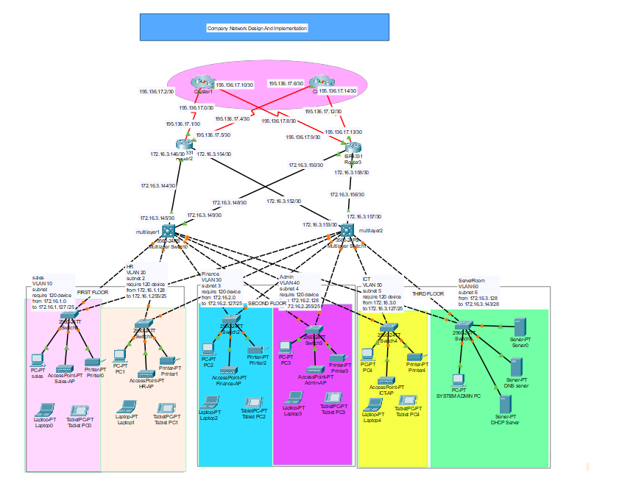

Connecting Between Routers Cores & ISPs

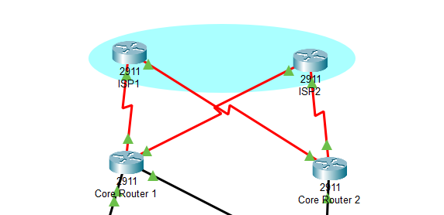

First we should turn off the Routers and put the HWC-2T part to make it available to Serial ports and then turn on the router then connected with each other by serial DCE
The serial DCE (Data Communications Equipment) cable is used to connect two routers via their serial interfaces.

Connecting Between Routers Cores & MultiSwitches and Switches
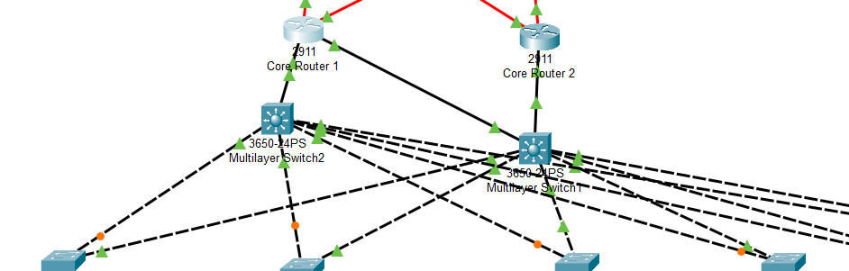

Copper Straight-Through Cable is used to connect different types of devices (e.g., routers to switches or PCs to switches). This cable ensures proper communication between layers in your network.

Connecting Between Switches and Department Devices

We Connect the switch to the PC , printer and The Accesses point By Copper Straight Through Cable
An Access Point (AP) is a networking device that allows wireless devices (like laptops, smartphones, and IoT devices) to connect to a wired network. It acts as a bridge between the wired network and Wi-Fi-enabled devices.
The Server Room has Pc and Servers
- Servers in the server room provide centralized services required by all departments.
- Static IPs are assigned to these servers to ensure their availability and accessibility.
- They interact with routers, switches, and access points to ensure seamless operation across the entire network.
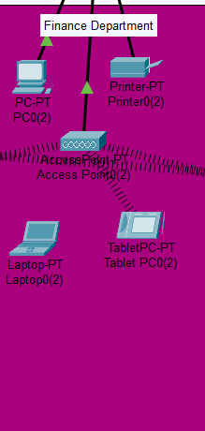
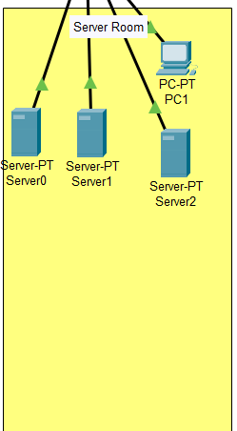

Important Step to add AC power Supply at Each Multi switch and turn on all ports in the Routers to ba able to be configured
Why ?
- Ensures stable operation for routing and switching functions.
- Prevents downtime and supports network reliability.

Network Configurations
- Switch Configuration at each Department
For example the HR Department
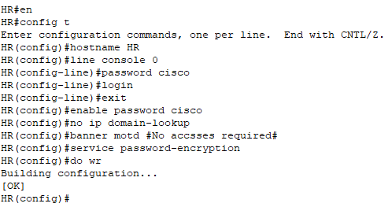

Commands Brief :
- Changed switch name to HR for identification.
- Set console and enable passwords for security.
- Disabled DNS lookup to avoid delays.
- Enabled password encryption for security.
- Set a login banner to warn unauthorized users.
- Saved the configuration to make sure the changes are kept.

Multi Layer Switch and Core Routers Configuration
The same config of the switch plus the SSH configuration
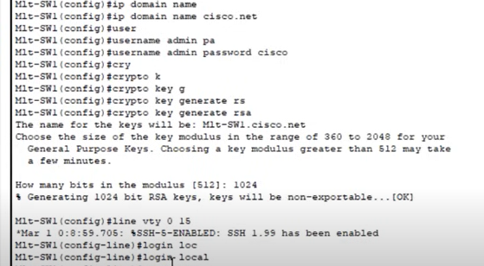

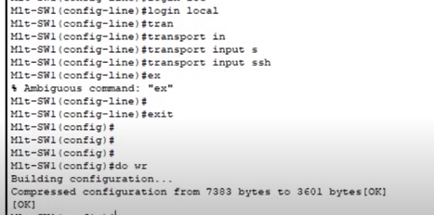

Commands Brief :
1. ip domain name cisco.net
- Sets the domain name for SSH.
2. username admin password cisco
- Creates a local user admin with password cisco for SSH access.
3. crypto key generate rsa
- Generates an RSA key for SSH encryption.
4. line vty 0 15
- Configures the lines for remote access (SSH/Telnet).
5. login local
- Forces the switch to use local user credentials for login.
6. transport input ssh
- Enables only SSH for remote access.
Important Step to add SSH version for core routers and multi switches
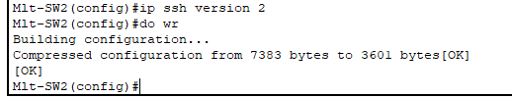

- VLAN Configuration at each Department
Switch at Each Department just it varies in Vlan number and name
Sales Vlan -> 10 & name -> Sales HR Vlan -> 20 &name -> HR
Finance Vlan -> 30 & name -> Finance ICT Vlan -> 40 & name -> ICT
Admin Vlan -> 50 & name -> Admin Server Vlan -> 60 & name -> Server
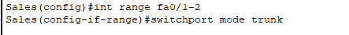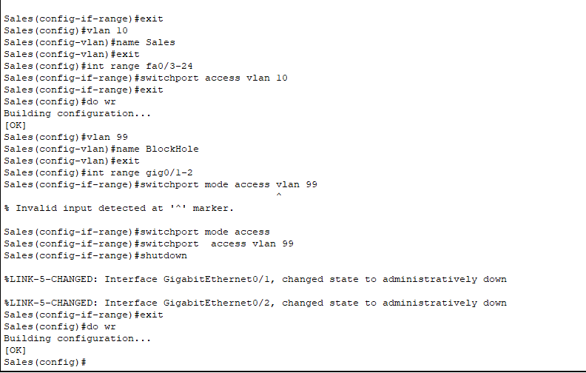
Commands Brief :
- int range fa0/1-2:
Selects interfaces fa0/1 to fa0/2.
- switchport mode trunk:
Sets interfaces to trunk mode, allowing multiple VLANs.
- vlan 10: Creates VLAN 10.
- name Sales: Names VLAN 10 as "Sales".
- int range fa0/3-24: Selects interfaces fa0/3 to fa0/24.
- switchport access vlan 10: Assigns VLAN 10 to the selected interfaces.
- vlan 99: Creates VLAN 99.
- name BlockHole: Names VLAN 99 as "BlockHole".
- int range gig0/1-2: Selects GigabitEthernet interfaces 0/1 to 0/2.
- switchport access vlan 99: Assigns VLAN 99 to the selected interfaces.
- shutdown: Disables the selected interfaces.
Security Configuration at Finance Department
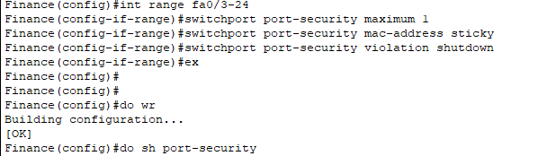

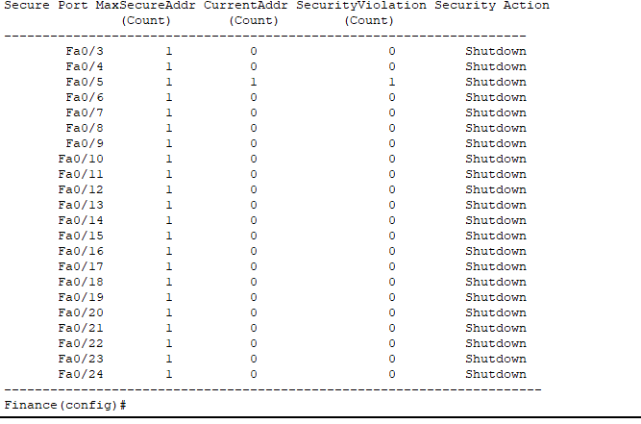

Commands Brief :
- do show port-security
  - Displays the port security configuration for the device.
- int range fa0/3-24
  - Selects interfaces fa0/3 to fa0/24 for configuration.
- switchport port-security maximum 1
  - Sets the maximum allowed MAC addresses per port to 1.
- switchport port-security mac-address sticky
  - Enables sticky MAC address learning, meaning the switch will automatically learn and store the MAC addresses connected to the port.
- switchport port-security violation shutdown
  - Configures the port to shut down if a security violation occurs.
VlANs Configuration at each MulitLayer Switches
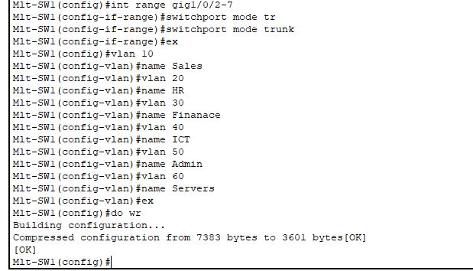
Commands Brief :
- switchport mode tr
  - (Typo) This command should be switchport mode trunk, which configures the selected interfaces to operate in trunk mode. Trunk mode allows the interface to carry traffic for multiple VLANs.
- switchport mode trunk
  - Configures the selected interfaces to trunk mode,
- vlan 10, vlan 20, vlan 30, vlan 40, vlan 50, vlan 60
  - Creates VLANs with IDs 10, 20, 30, 40, 50, and 60 on the switch.
- name Sales, name HR, name Finance, name ICT, name Admin, name Servers
  - Assigns names to the created VLANs: Sales, HR, Finance, ICT, Admin, and Servers.
Subnetting and IP addressing :
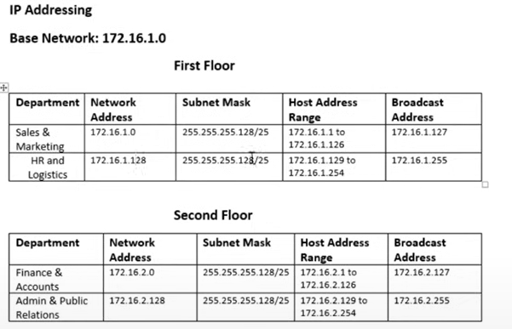
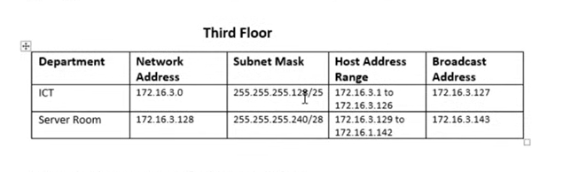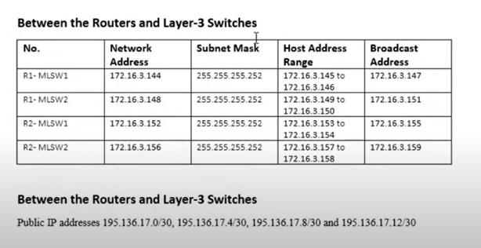

Multi switch ports Configuration to be perform as Router
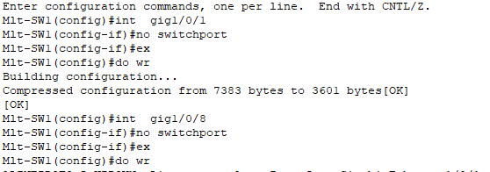

Commands Brief :
- int gig1/0/1
  - Entered configuration mode for the interface GigabitEthernet 1/0/1.
- no switchport
  - Changed the interface from Layer 2 (Switchport) to Layer 3 (Router), enabling IP-based routing.
IP addressing of Muti-Sw1:
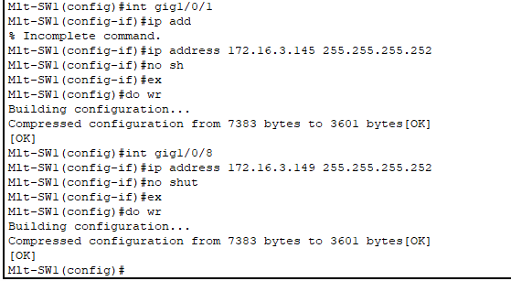

IP addressing of Muti-Sw2:
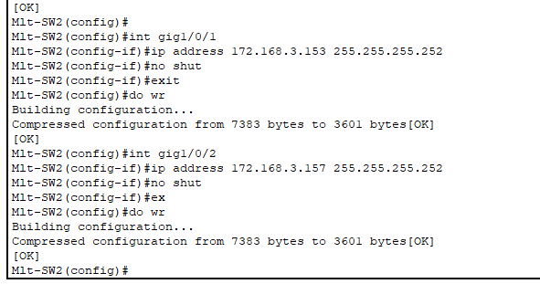
IP addressing of Router-1:
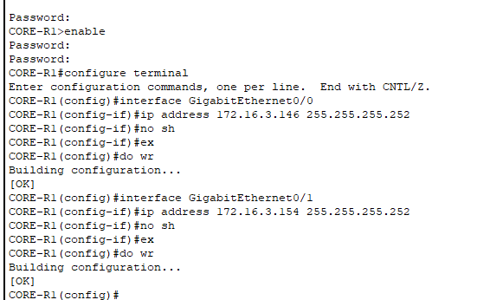
IP addressing of Router-2:
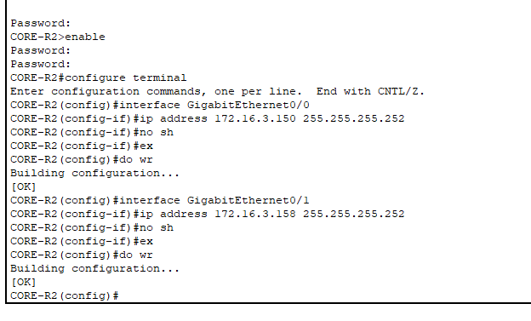

IP addressing of Router-1 with ISP1 & ISP2:
The Clock Rate is the value that determines the data transfer speed between devices connected via a serial link.
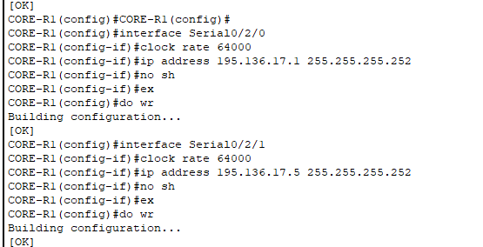
IP addressing of Router-2 with ISP1 & ISP2:
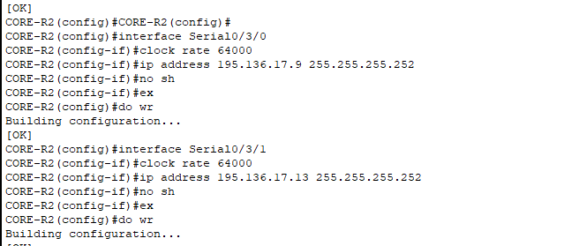

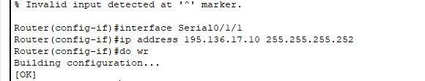
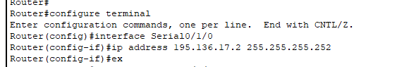
IP addressing of ISP1 & ISP2:
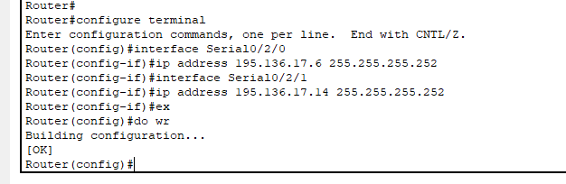
OSPF for Routers and switches :
For multi-SW1:
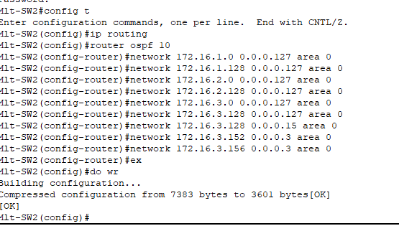
Commands Brief :
- router ospf 10:
Activates the OSPF (Open Shortest Path First) routing protocol on the device with a process ID of 10.
- network ... area 0:
Defines the networks (subnets) that OSPF will advertise and include in Area 0 (the backbone area). Each network command specifies a subnet using a network address
For multi-SW2:
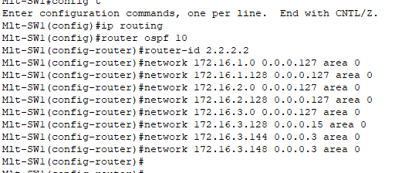
For Router1:
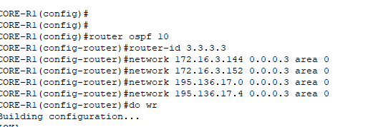
For Router2:
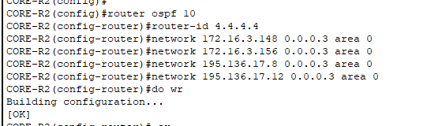

For ISP Router 1 :
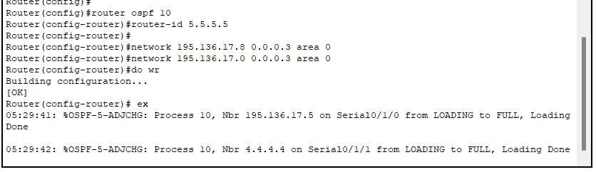
For ISP Router 2 :
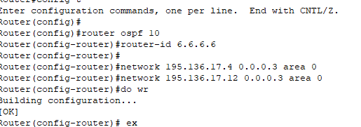
Static IP address to ServerRoom Devices
DHCP Server
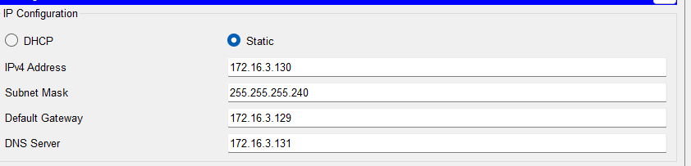
PC
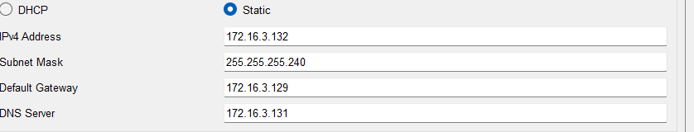
DNS Server
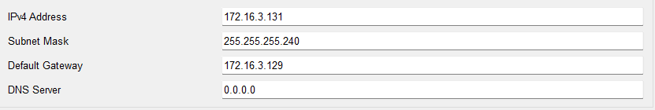
DHCP Server Configuration
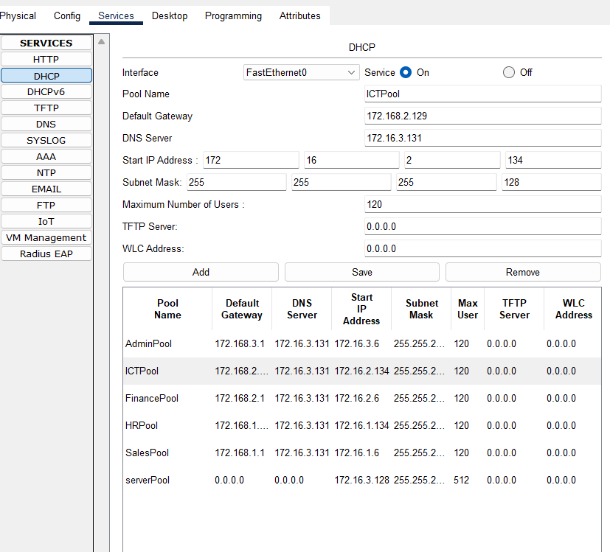

DNS Server Configuration
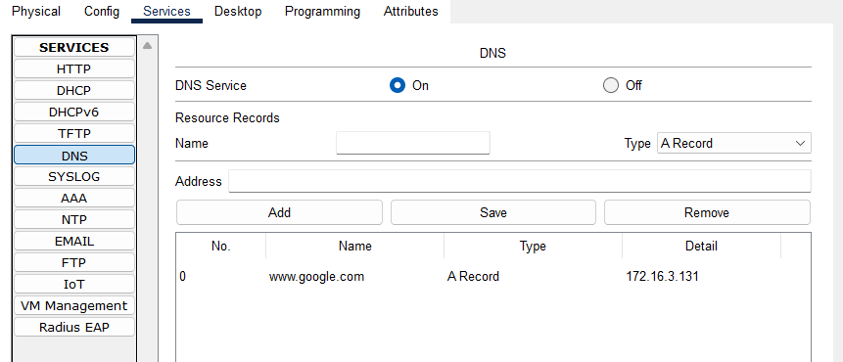
Inter-VLAN Routing
Through Multi-SW1 & Multi-SW2
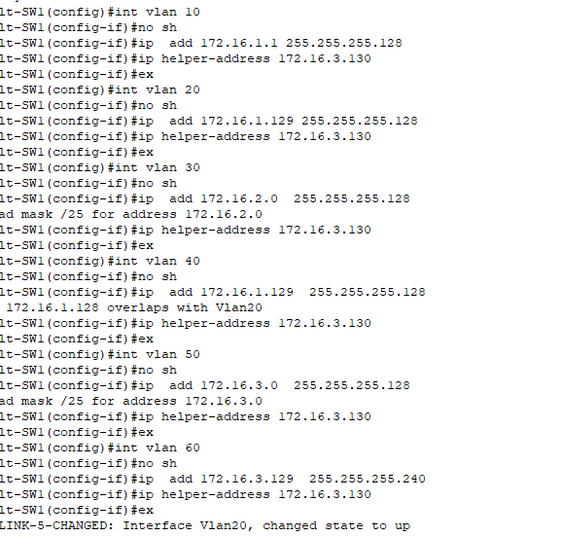

Wireless Network Configuration
For each tablet ant laptop in each department
Set-up the Accesses point first password
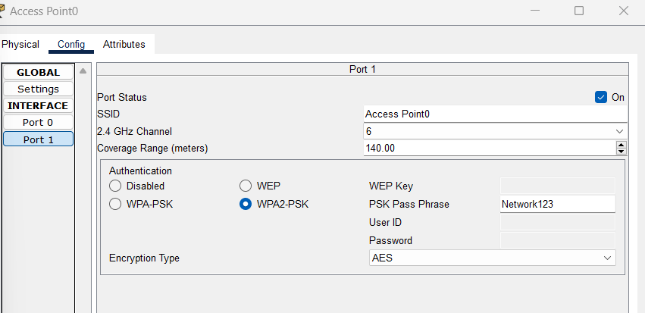
Set-up the Laptop to add WPC300N to be able connect wireless
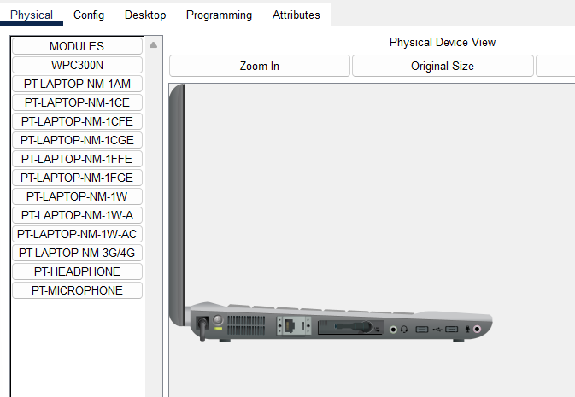
Then Connect to the AC
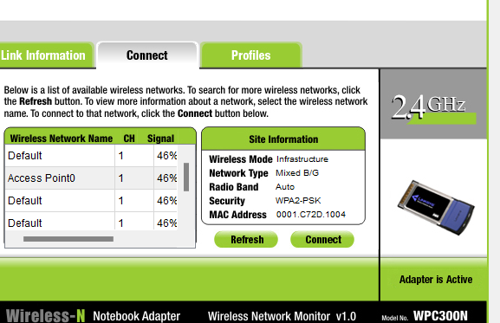

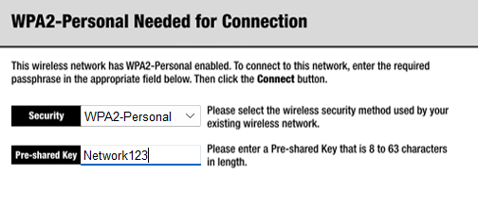
Set Up the Tablet to connect to the AC
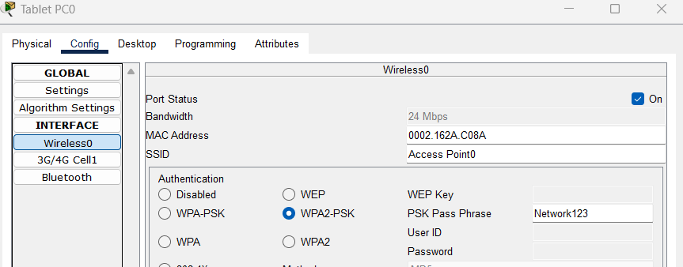

PAT and Access Control List
For Router 1
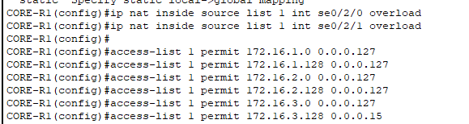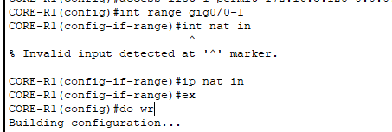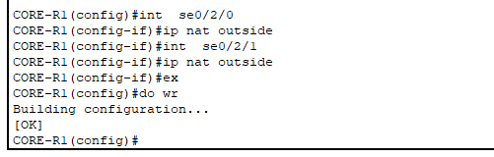
For Router2
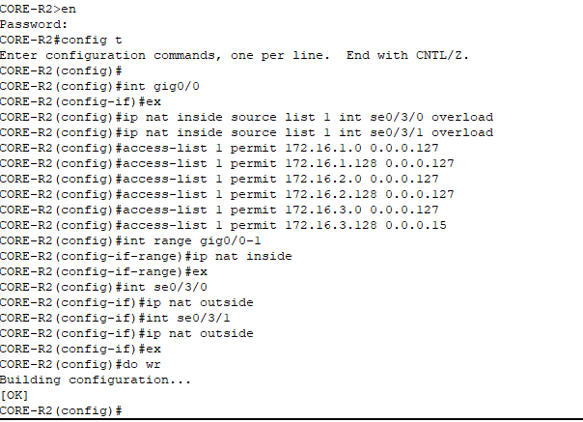

Commands Brief :
NAT Configuration:
- The commands ip nat inside source list 1 int se0/2/0 overload and ip nat inside source list 1 int se0/2/1 overload configure NAT to translate internal network addresses (defined in Access List 1) to the external IP addresses of interfaces se0/2/0 and se0/2/1 using PAT (Port Address Translation).
Access List Configuration:
- The access-list 1 permit commands define the internal subnets allowed for NAT translation:
  - 172.16.1.0/25
  - 172.16.1.128/25
  - 172.16.2.0/25
  - 172.16.2.128/25
  - 172.16.3.0/25
  - 172.16.3.128/28.
This ensures only the specified subnets can use the NAT configuration for external connectivity.
Default Static Route :
For Mult-SW1 and SW2
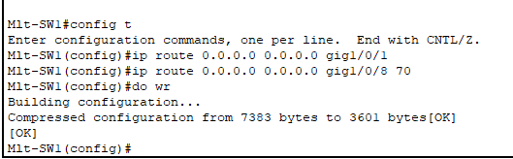

For Router one and two
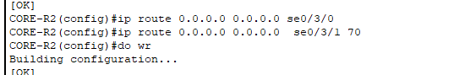
For Enabling DHCP for PC and Printer at each department
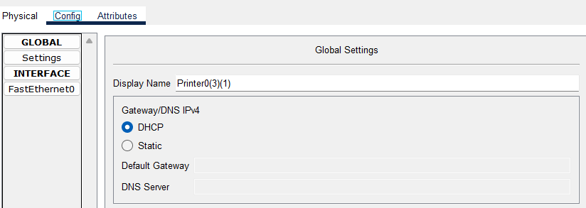
Testing The Network Let the PC in Sales Department connect to Pc in ICT Department
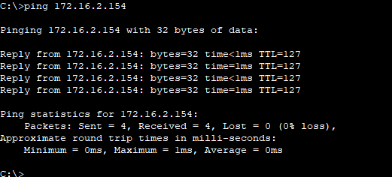

Testing The Network SSH
